***Flow Chart***

**Flow Chart Symbols Representation: -**

***Start/Stop***

***Process***

***Condition Making***

***Flow/ Direction***

***Data Input/output***

* **Operators: -**

**+, -, *, %, /**

***Arithmetic Operator-***

***Comparison Operator-***

**>, <, ==, >=, <=**

* **Normal Flow Chart Diagram-**

Flow Chart diagram helps to understand the work easily and in better way to work on that.

Basically it bifurcates the whole process and divides the steps to ensure that we are going properly to our destination of project in a flow.

* **Simple Tea Making Steps**

START

*Vessel, Tea, Sugar, Water, Milk*

Process on tea (cooking)

Cooked

STOP

* Algorithm for Summing

STOP

Sum (print or output)

Sum = x + y

x, y, sum

START

* Apply 4 numbers of variables in a flow chart by using max saving method

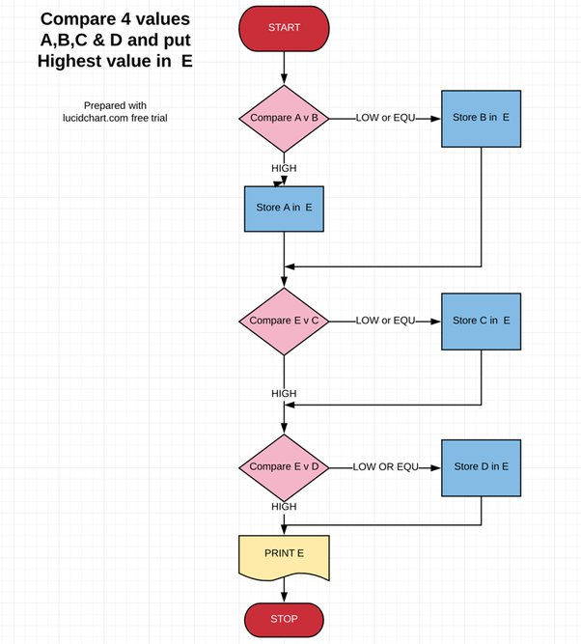

* Modulus even and odd numbers
* Formulae: a%2==0

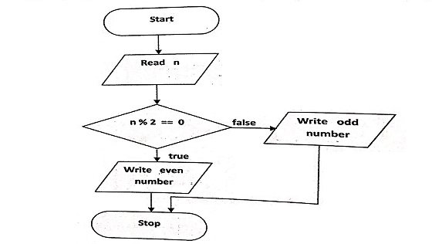

* Print a table in a flow chart
* For int i < = 10, i+1

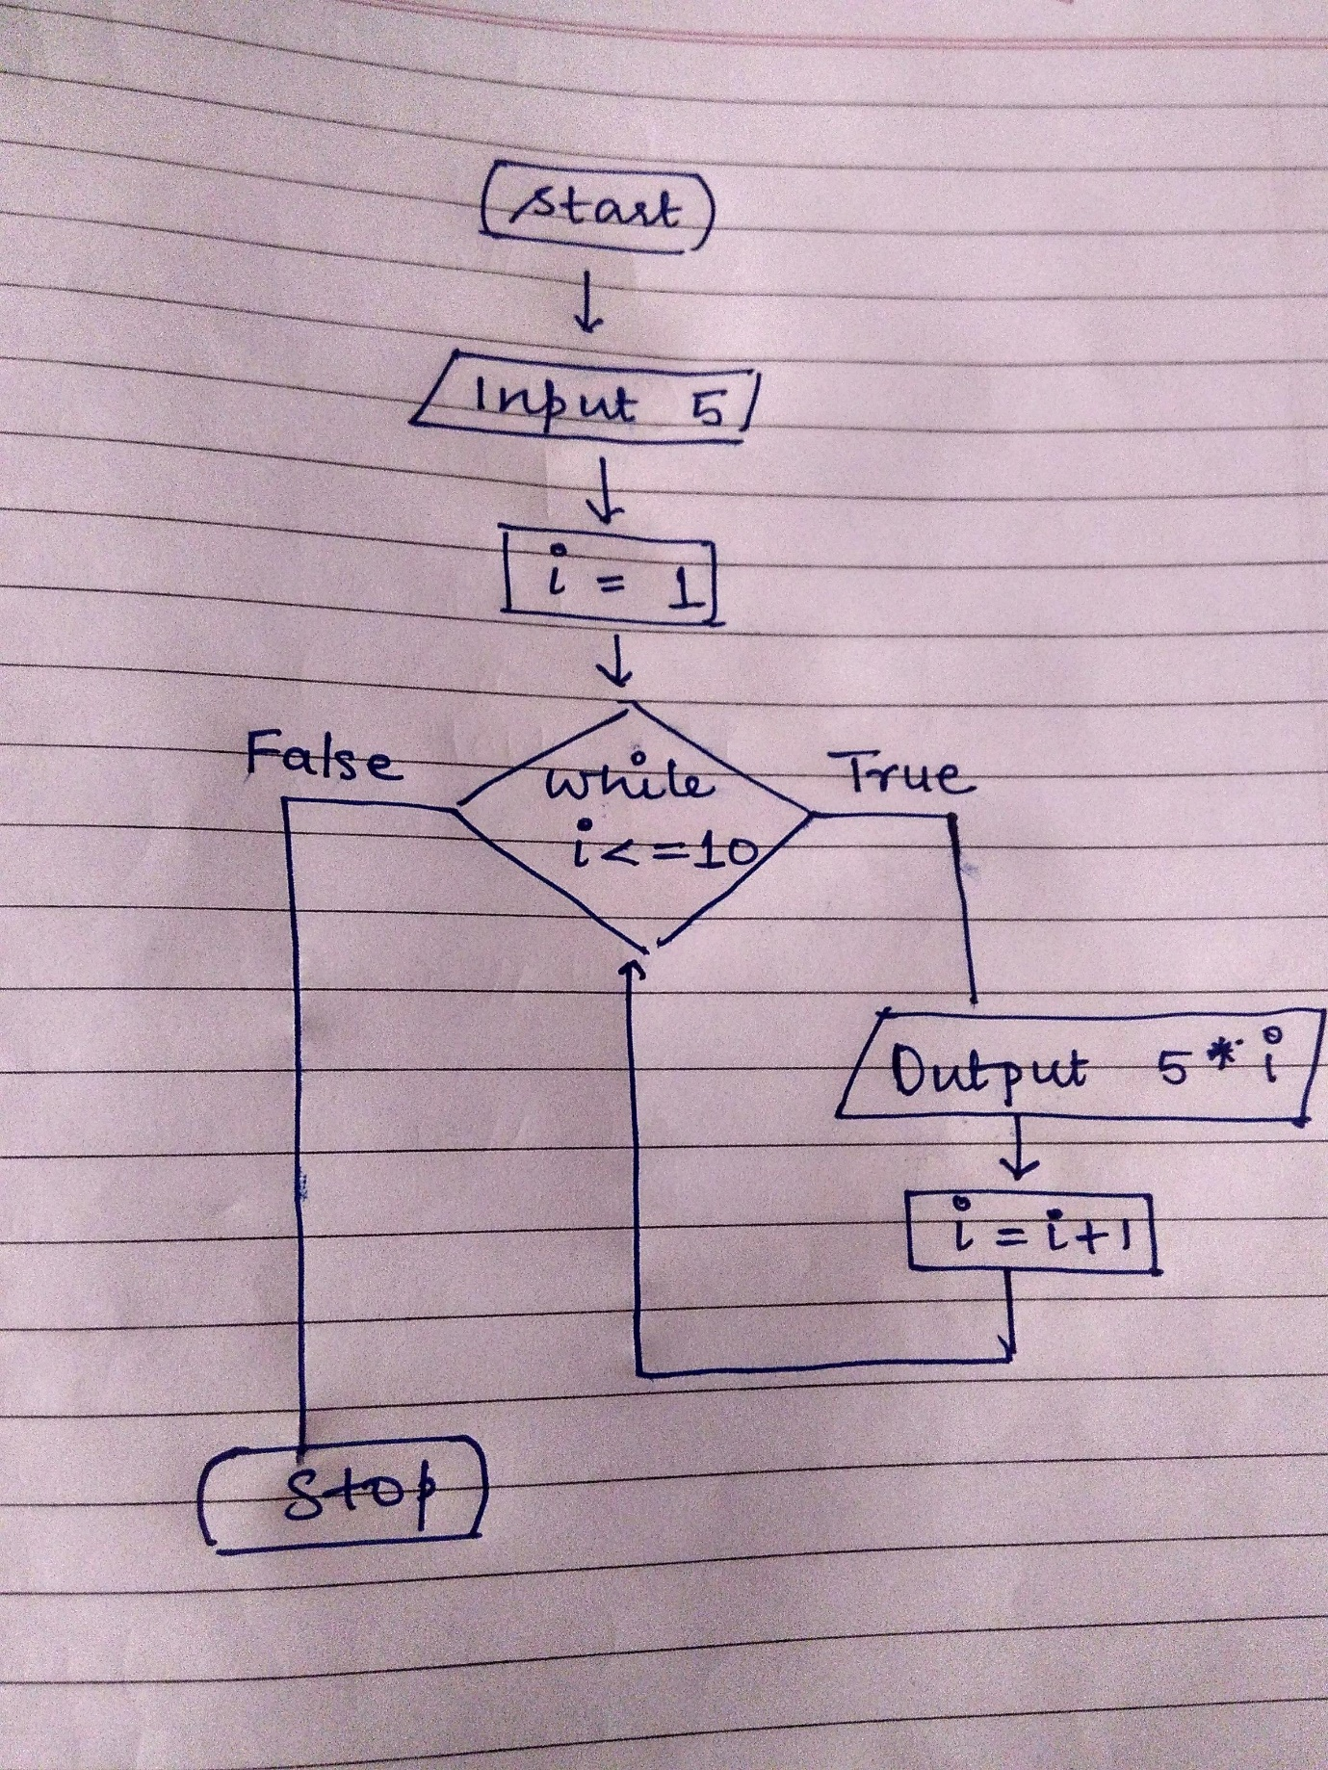

* Flow Chart for < > of three numbers

Start

X, y, z, a

X is greater

X is greater

X is greater

A is greater

Z is greater

STOP

X is >

x>a

x>z

If x>a

A is >

If x >z

If x>y